Software Requirement System

Greenhouse Farm Website

Asiedu- Danquah Yaw Osei (5948016)

Michael Gyimah (5951916)

Nnuro Steven Kofi (5953616)

Brenden Asare (5947616)

Afful Franccis Baah Amponsah(5945616)

Avevor Cyril Mawunyo (5948416)

Goode Kyereme Richmond(5951316)

Table of Contents  
1.Introduction...............................................................................................................................................1  
1.1 Purpose................................................................................................................................................1  
1.2 Scope...................................................................................................................................................1  
1.3 Definitions, acronyms, and abbreviations...........................................................................................1  
1.4 References...........................................................................................................................................2  
2. Overall description....................................................................................................................................4  
2.1 Product perspective.............................................................................................................................4  
2.2 Product functions ................................................................................................................................4  
2.3 User characteristics .............................................................................................................................5  
2.4 Constraints ..........................................................................................................................................5  
2.5 Assumptions and dependencies ..........................................................................................................5  
2.6 Apportioning of requirements.............................................................................................................6  
3. Specific requirements................................................................................................................................7  
3.1.1 User interfaces .............................................................................................................................7  
3.1.2 Hardware interfaces .....................................................................................................................8  
3.1.3 Software interfaces.......................................................................................................................8  
3.1.4 Communications interfaces..........................................................................................................9  
3.2 Functional requirements......................................................................................................................9  
3.2.1 User Class 1 - The User ...............................................................................................................9  
3.2.2 User Class 2 - Farmer Owner ...............................................................................................14  
3.2.3 User Class 3 - Administrator......................................................................................................18  
3.3 Performance requirements ................................................................................................................21  
3.4 Design constraints.............................................................................................................................23  
3.5 Software system attributes ................................................................................................................23  
4. Prioritization and Release Plan ...............................................................................................................27  
4.1 Choice of prioritization method ........................................................................................................27  
Appendix I: Selection for Cost-Value Approach........................................................................................29  
Appendix II: Prioritization Result of 10 selected Requirements Using Cost-Value Approach ..................32  
Appendix III: Five-Way Priority Scheme...................................................................................................36  
Appendix IV: Release Plan.........................................................................................................................47  
Appendix V: I-star ......................................................................................................................................55

1. **Introduction** This documentation gives a scope description and overview of what the project is about.This document is also well described and a list of abbreviations and definitions is provided.

**1.1 Purpose** The purpose of this document is to give a detailed description of the requirements for the “Greenhouse Farm Website” and how it will be used . It will illustrate the purpose and complete description for the development of the website. It will also explain system constraints, interface and interactions with other external applications. This document is primarily intended to be proposed to a customer for its approval and a reference for updating the website for the development team.

**1.2 Scope** The “Greenhouse Farm Website” is a website which helps people to buy and sell foodstuffs such as vegetables, fruits etc, based on the user’s current position and other specification like price, dish and more.Farm owners can provide their greenhouse information using the web-portal. This information will act as the bases for the search results displayed to the user. An administrator also uses the web-portal in order to administer the system and keep the information accurate. The administrator can, for instance, verify the farmer and manage user information.  
 Furthermore, the website needs both the internet and process tracker to fetch and display results. All system information is maintained in a database, which is located on a web-server. The website also interacts with the process tracker which is required to be an already installed application on the website. By using the process tracker, users can determine the progress of the processing of their products and when exactly they will receive them. The application also has the capability of representing both summary and detailed information.

**1.3 Definitions, acronyms, and abbreviations**

|  |  |
| --- | --- |
| Term | Definition |
| Greenhouse | Is a structure enclosed and used for the cultivation or protection of tender plants. |
| GHG | Greenhouse Gas |
| GHGRP | Greenhouse Gas Emission Reporting Program |
|  |  |
|  |  |
|  |  |

**1.4 References**

**1.5 Overview** The remainder of this document includes three chapters and appendixes. The second one provides an overview of the system functionality and system interaction with other systems. This chapter also introduces different types of farmers and their interaction with the system and also user interactions. Further, the chapter also mentions the system constraints and assumptions about the website.The third chapter provides the requirements specification in detailed terms and a description of the different system interfaces.

Different specification techniques are used in order to specify the requirements more precisely for different audiences.The fourth chapter deals with the prioritization of the requirements. It includes a motivation for the chosen prioritization methods and discusses why other alternatives were not chosen.  
 The Appendixes in the end of the document include the all results of the requirement prioritization and a release plan based on them.

1. **Overall description** This section will give an overview of the website. The website will be explained in its context to show how the website interacts with other websites and introduce the basic functionality of it. It will also describe what type of farmer that will use the website and what functionality is available for each type. At last, the constraints and assumptions for the website will be presented.
   1. **Product perspective**This system will consist of one part: one web portal. The web portal will be used for managing the information about the greenhouse farms and also help place orders for delivery.  
      The web portal will need to communicate to a process tracker within the website. Since this is a data-centric product it will need somewhere to store the data. For that, a database will be used. Web portal will communicate with the database, however in slightly different ways. The web portal will only use the database to get data and will also add and modify data. All of the database communication will go over the Internet.
   2. **Product functions**With the web portal, the users will be able to search for products greenhouse farms. The result will be based on the criteria the user inputs. There are several search criteria and it will be possible for the administrator of the system to manage the options for those criteria that have that.The result of the search will be viewed either in a list view or in a map view, depending on what criteria included in the search. The list view will have one list item for each greenhouse farm matching the search criteria and show a small part of the farm information so the user can identify the greenhouse farm. The map view will show each greenhouse farm location as a pin on the map as well as the user’s own location. In both views the users will be able to either select a greenhouse farm as target destination or get information how to get there, or view the information of a specific farm.The web portal will provide functionality to manage the system and the restaurant information. It will also provide information about the website, for example show when there is a new update.
   3. **User characteristics**There are three types of users that interact with the system: users, greenhouse farm owners and administrators. Each of these three types of users has different use of the system so each of them has their own requirements.The web portal users can only use the application to find a greenhouse farm. This means that the user have to be able to search for farms, choose a greenhouse farm from that search and then navigate to it. In order for the users to get a relevant search result there are multiple criteria the users can specify and all results matches all of those.The greenhouse farm owners will also us the web portal. There they will manage the information about their farm, for example a description of the farm,contact information and their menu.The administrators also only interact with the web portal. They are managing the overall system so there is no incorrect information within it. The administrator can manage the information for each greenhouse farm as well as the options for both the mobile application users and the greenhouse farm owners.

**2.4 Constraints**The website is constrained by the system interface to the process tracker with the user’s particular location. Since there are multiple system and multiple process trackers, the interface will most likely not be the same for every one of them.  
The Internet connection is also a constraint for the website. Since the website fetches data from the database over the Internet, it is crucial that there is an Internet connection for the application to function.

**2.5 Assumptions and dependencies**One assumption about the product is that it will always be used on mobile phones or any computing device that have enough performance. If the phone does not have enough hardware resources available for the website, for example the users might have allocated them with other applications, there may be scenarios where the website does not work as intended or even at all.  
Another assumption is that the process tracker in all phones and other computing devices work in the same way. If the phones have different interfaces to the process tracker, the application need to be specifically adjusted to each interface and that would mean the integration with the process tracker would have different requirements than what is stated in this specification.

**2.6 Apportioning of requirements**In the case that the project is delayed, there are some requirements that could be transferred to the next version of the application. Those requirements are to be developed in the third release, see Appendix IV

1. **Specific requirements**This section contains all of the functional and quality requirements of the website. It gives a detailed  
   description of the website and all its features.

**3.1 External interface Requirements**This section provides a detailed description of all inputs into and outputs from the system. It also gives a  
description of the hardware, software and communication interfaces and provides basic prototypes of the  
user interface.

.  
3.1.1 User interfaces  
A first-time user of the web portal should see the log-in page when he/she opens the website page ,  
see Figure 2. If the user has not registered, he/she should be able to do that on the log-in page.  
If the user is not a first-time user, he/she should be able to see the search page directly when the  
website is opened, see Figure 3. Here the user chooses the type of search he/she wants to conduct.  
Every user should have a profile page where they can edit their e-mail address, phone number and  
password, see Figure 4. Also, the user can set the website to his/her preferred language. The  
“P” icon shows where the user can click to navigate to his/her profile page.  
In Figure 5, the list view for the results is shown. When a user searches by price, this view should be the  
default one. The sorting header allows the user to sort the results according to price, farmer name,  
distance, restaurant type and specific foodstuffs. Each result item includes information about the greenhouse farm, a link to the greenhouse web-page and an information link, which provides a more detailed description of the greenhouse. There is also a filtering option, where the user can choose to filter the results by increasing  
or decreasing the price or distance range, see Figure 7.  
In the map view each greenhouse farm is represented by a pin, see Figure 6. Next to every pin there is an  
information link which provides a more detailed description of the greenhouse, as mentioned for the list  
view. The same filtering option, as for the list view, is included in the map view.

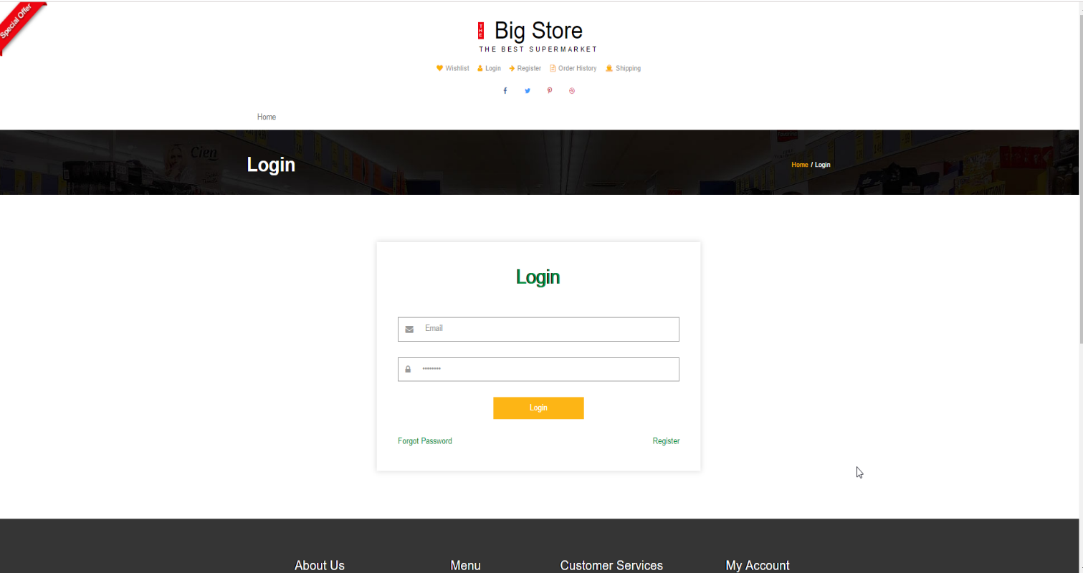

Fig 2.

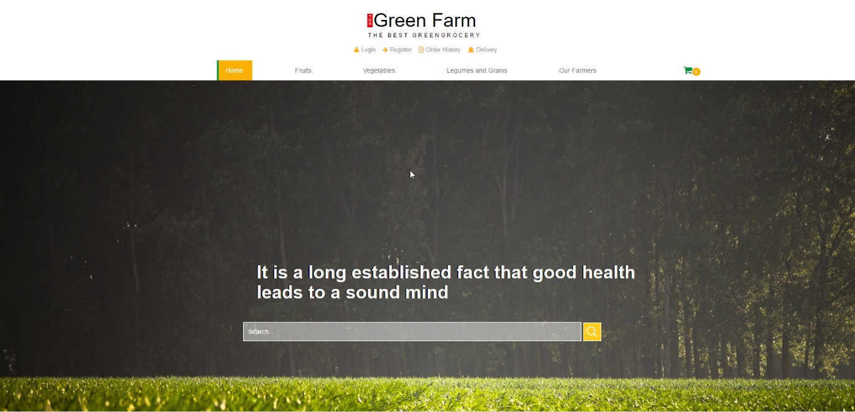

Fig 3. Search on the homepage

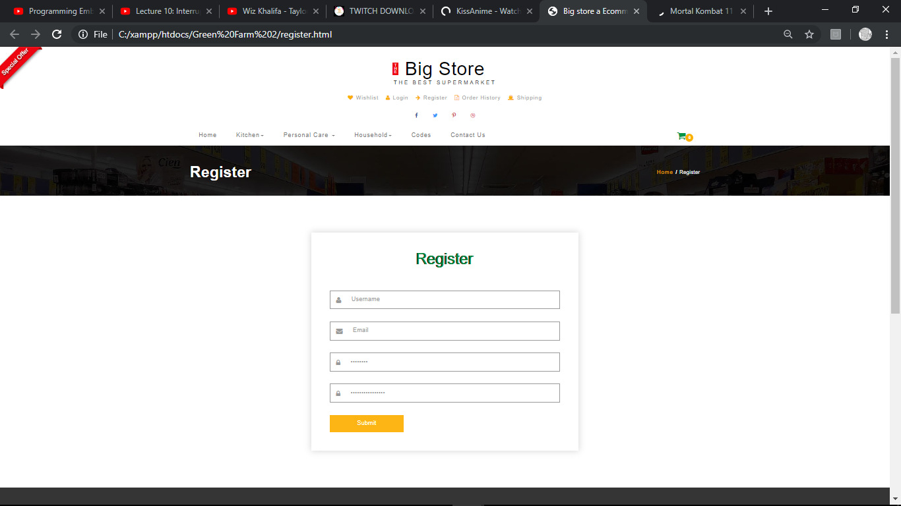

Figure 4 - Register Page

**Figure 2 - Login page Figure 3 – Search page Figure 4 – Register page**   
The greenhouse and administrators interact with the system through a web-portal, see Figure 8. A  
greenhouse farmer should be able to register on the web-portal in order to log in and manage the restaurant  
information. An administrator should also be able to log in to the web-portal where he/she can administer  
the system by for instance editing restaurant or user information.

**3.1.2 Hardware interfaces**Since neither the mobile application nor the web portal have any designated hardware, it does not have  
any direct hardware interfaces. The physical GPS is managed by the GPS application in the mobile phone  
and the hardware connection to the database server is managed by the underlying operating system on the  
mobile phone and the web server.  
**3.1.3 Software interfaces**The mobile application communicates with the GPS application in order to get geographical information  
about where the user is located and the visual representation of it, and with the database in order to get the  
information about the restaurants, see Figure 1. The communication between the database and the web  
portal consists of operation concerning both reading and modifying the data, while the communication  
between the database and the mobile application consists of only reading operations.

**3.1.4 Communications interfaces**The communication between the different parts of the system is important since they depend on each  
other. However, in what way the communication is achieved is not important for the system and is  
therefore handled by the underlying operating systems for both the mobile application and the web portal.

**3.2 Functional requirements**

This section includes the requirements that specify all the fundamental actions of the software system

***3.2.1.1 Functional requirement 1.1***

TITLE: Web browser will be needed

DESCRIPTION: A user should be able to download or have a web browser on his or her personal computer or mobile phone.

DEP: None

***3.2.1.2 Functional requirement 1.2***

**ID: FR2** TITLE: User registration – Web portal

DESC: Given that a user has downloaded the web browser then the user should be able to register through the web portal. The user must provide user-name, password and e-mail address. The user can choose to provide a regularly used phone number.

DEP: FR1

***3.2.1.3 Functional requirement 1.3***

**ID: FR3** TITLE: User log-in – Web portal

DESC: Given that a user has registered, then the user should be able to log in using the web portal. The log-in information will be stored on the phone or computer and in the future the user should be logged in automatically.

DEP: FR1, FR2

***3.2.1.4 Functional requirement 1.4***

**ID: FR4** TITLE: Retrieve password

DESC: Given that a user has registered, then the user should be able to retrieve his/her password by e-mail

DEP: FR3

***3.2.1.5 Functional requirement 1.5***

**ID: FR5** TITLE: Web browser – Search

DESC: Given that a user is logged in to the web portal, then the first page that is shown should be the search page. The user should be able to search for a greenhouse farm, according to several search options. The search options are Price, Destination, foodstuff type and Specific fruits. There should also be a free-text search option. A user should be able to select multiple search options in one search.

DEP: FR4

***3.2.1.6Functional requirement 1.6***

**ID: FR6** TITLE: Web portal - Search result in a list view

DESC:

• Search results can be viewed in a list. Each element in the list represents a specific greenhouse farm. Each element should include the greenhouse farm name, telephone number, type of foodstuffs, distance according to the user’s position, average price, a short two-line description, a link to the farmer’s web-page and an information link.

• There should be maximally 100 results displayed. If the result contains more greenhouse farms than what can be displayed on the screen at one time, the user should be able to scroll through them.

• When searching by price the greenhouse farm should be sorted according to the following order:

1. average price

2. distance

3. greenhouse type

4. specific foodstuffs

• When searching by a search option, other than price, the greenhouse farm should be sorted according to the following order:

1. distance

2. average price

3. greenhouse type

4. specific foodstuff

• The list view should include a header with different selectable sorting options.

• The list view should include a button that, when selected, should display different filtering options in a filtering menu.

DEP: FR5

***3.2.1.7 Functional requirement 1.7***

**ID: FR7** TITLE: Web portal- Selecting the information link

DESC: A user should be able to select the information link, which is included on all result items. The link will direct the user to an information page, which includes a picture of the greenhouse farm, the farm name, address, phone number, e-mail address, type of foodstuff, average price, greenhouse farm description, description and price of the different foodstuffs.

DEP: FR6

***3.2.1.8 Functional requirement 1.8***

**ID: FR8** TITLE: Web portal - Search by price

DESC: A user should be able to input a maximum and a minimum price range. The result is displayed in a list view by default.

DEP: FR7

***3.2.1.9 Functional requirement 1.9***

**ID: FR9** TITLE: Accepted input for price and destination search

DESC: Integers should be accepted as input when a user searches by price or destination. If the system receives an invalid input the user should be informed and prompted to insert an accepted input. DEP: FR8

***3.2.1.10Functional requirement 1.10***

**ID: FR10** TITLE: Web portal - Search by specific foodstuff

DESC: A user should be able to select a specific dish in a given list as input. The result is displayed in a list view form.

DEP: FR5

***3.2.1.11 Functional requirement 1.11***

**ID: FR11** TITLE: Web Portal- Free-text search

DESC: A user should be able to conduct a search by providing either greenhouse farmer name, greenhouse farmer description, greenhouse address, restaurant type or restaurant menu in the free-text search field. The result is displayed in a list view form by default.

DEP: FR5

***3.2.1.12 Functional requirement 1.12***

**ID: FR12** TITLE: Web portal - No match found

DESC: If no match is found the user should be informed but kept on the search page in order to get the possibility to conduct a new search right away.

DEP: FR5

***3.2.1.13 Functional requirement 1.13***

**ID: FR13** TITLE: Web portal- Sorting results

DESC: When viewing the results in a list, a user should be able to sort the results according to price, distance, greenhouse type, specific foodstuff or greenhouse farm name.

• When sorting by greenhouse name, specific foodstuff or greenhouse type the results should be ordered alphabetically.

• When sorting by price the results should be ordered from cheapest to most expensive.

• When sorting by distance the results should be ordered from closets to furthest distance according to the user’s position.

When the sort button for a specific search option is clicked, then the order should be reversed and ordered in a descending matter. If the sort button is clicked again the order of the results should be reverse.

***3.2.1.14 Functional requirement 1.14***

**ID: FR20** TITLE: Web portal - Filtering results

DESC: When viewing the results in a list or , a user should be able to filter the results in a filtering menu. The filtering options include:

• increasing or decreasing the maximum distance

• increasing or decreasing the maximum price

• choosing a greenhouse farm type

• choosing a specific foodstuff

When filtering the results, only the existing results shall be affected and a new search query should not be sent.

DEP: FR5

***3.2.1.16 Functional requirement 1.16***

**ID: FR16** TITLE Web portal - Profile page

DESC: On the web portal, a user should have a profile page. On the profile page a user can edit his/her information, which includes the password, e-mail address and phone number. A user should also be able to choose what language the web portal should be set to. The different language choices are Swedish, English, Spanish and French. RAT: In order for a user to have a profile page on the mobile application. DEP: FR1

**3.2.2 User Class 2 – Greenhouse Farmer Owner**

***3.2.2.1 Functional requirement 2.1***

**ID: FR22 Feature: Create an account** In order to create an account .A greenhouse farmer owner Should register on the web-portal.

**Scenario: Required information for registration :**Given the farm house owner wants to create an account And the greenhouse owner does not have an account.When the greenhouse farm owner registers on the web-portal by providing user-name and password and address and e-mail address and phone number .Then the greenhouse farm owner should be able to apply for verification.

**Scenario: Full information for registration** Given the greenhouse farm owner wants to create an account and the greenhouse farmer owner does not have an account ,when the farm owner registers on the web-portal by providing username , password , address , e-mail address And phone number Then the greenhouse owner should be able to apply for verification.

**Scenario: Confirmed registration** Given the greenhouse owner has applied for verification and has not received a confirmation e-mail after registration .When the farm owner receives a confirmation e-mail then the greenhouse owner should be able to log in.

***3.2.2.2 Functional requirement*** 2.2

**ID: FR23 Feature: Greenhouse owner log-in** In order to use the system A farm owner should be logged in to the web-portal.

**Scenario: Successful log-in** Given the greenhouse farm owner wants to log in, when the farm owner logs in with his/her account, Then the greenhouse farm owner should be logged in as a farm owner

**Scenario: Retrieve password** Given the farm house owner wants to log in, and has lost the password when the greenhouse farm owner enters his/her email address in the “Retrieve password” form and submits the form then the farm owner should receive an email containing the password.

***3.2.2.3 Functional requirement 2.3***

**ID: FR24 Feature: Manage information** In order to manage information. A farm owner should be logged in to the web-portal.

**Scenario: Show fields for managing information** Given the greenhouse owner is logged in when the farm owner wants to manage information. Then the greenhouse farm owner should be able to manage information in a form.

**Scenario: Filling in mandatory fields** Given the farm owner wants to fill in the mandatory fields of the form,when the greenhouse owner provides average price And address And e-mail address And phone number and farm house name,then the greenhouse owner has filled the mandatory fields of the form.

**Scenario: Filling in optional fields** Given the greenhouse owner of a farm house wants to fill in optional fields in the form,when the farm owner provides greenhouse farm description and menu and type of greenhouse farm and picture of farm and mobile phone. Then the greenhouse farm owner has filled in optional fields in the form.

**Scenario: Filling in menu field** Given that the green house owner wants to fill in the menu field in the form when the farm owner provides foodstuff name and foodstuff description And foodstuff price then the greenhouse owner has filled in the menu field in the form.

**Scenario: Adding information with mandatory fields** Given the greenhouse owner has filled in the mandatory fields of the form,when the farm owner submits the form then the information about the farm house should be added.

**Scenario: Adding information with mandatory and optional fields** Given the greenhouse owner has filled in the mandatory fields of the form and filled in one or more optional fields of the form when the greenhouse owner submits the form then the information about the greenhouse farm should be added.

**Scenario: Deleting information** Given the greenhouse owner is logged in and information exists when the farm owner deletes information then the information should be deleted.

**Scenario: Editing information** Given the greenhouse farm owner is logged in And information exists When the farm owner edits information Then the information should be edited.

**3.2.3 User Class 3 - Administrator**

***3.2.3.1 Functional requirement 3.1***

**ID: FR26 Feature: Administrator log in** In order to administer the system an administrator should be logged in to the web-portal.

**Scenario: Successful log-in** Given the administrator wants to log in when the administrator logs in with an administrator account, then the administrator should be logged in as an administrator.

***3.2.3.2 Functional requirement 3.2***

**ID: FR27 Feature: Verify greenhouse farm owner** In order to allow a farm house owner to use the system an administrator should be able to verify the greenhouse farm owner.

**Scenario: Verify a greenhouse farm owner** Given the administrator is logged in when the administrator verifies a farm owner, then the farm owner should be able to log in and the farm house owner should be notified by a confirmation email.

**Scenario: Reject a greenhouse farm owner** Given the administrator is logged in,when the administrator rejects a farm owner. Then the greenhouse farm owner should not be able to log in and the farm owner should be notified by a rejection email.

***3.2.3.3 Functional requirement 3.3***

**ID: FR28 Feature: Manage greenhouse types** In order to have a list of greenhouse farm types,an administrator should be able to manage the greenhouse types.

**Scenario: Add a new greenhouse type** Given the administrator is logged in .When the administrator creates a new greenhouse type then the new greenhouse type should be added to the list of greenhouse farm.

**Scenario: Editing an existing greenhouse farm type** Given the administrator is logged in,when the administrator edits an existing farm type then the farm type should be updated in the list of farm types

**Scenario: Delete a greenhouse farm type** Given the administrator is logged in, when the administrator deletes a greenhouse farm type then the deleted farmhouse type should be removed from the list of greenhouse farm types.

***3.2.3.4 Functional requirement 3.4***

**ID: FR29 Feature: Manage foodstuffs and fruits** In order to have a list of foodstuff and fruit an administrator should be able to manage the foodstuff and fruit.

**Scenario: Add a foodstuff and fruit:** Given the administrator is logged in when the administrator creates a new foodstuff then the new foodstuff and fruit should be added to the list of foodstuff

**Scenario: Editing a foodstuff and fruit:** Given the administrator is logged in when the administrator edits a foodstuff and fruit.then the foodstuff and fruit should be updated in the list of foodstuffs and fruits

**Scenario: Delete foodstuffs and fruits:** Given the administrator is logged in when the administrator deletes a foodstuff or fruit, then the deleted foodstuff or fruit should be removed from the list of foodstuffs and fruits

***3.2.3.5 Functional requirement 3.5***

**ID: FR30 Feature: Manage greenhouse farm information** In order to manage greenhouse farm information. An administrator should be logged in to the web-portal.

**Scenario: Add greenhouse farm information** Given the administrator is logged in when the administrator adds greenhouse farm information then the information should be added to the farm.

**Scenario: Delete greenhouse farm information** Given the administrator is logged in and information about a greenhouse farm exists when the administrator deletes the information  
Then the information about the greenhouse farm should be deleted.

**Scenario: Edit greenhouse farm information**Given the administrator is logged in  
And information about a greenhouse farm exists  
When the administrator edits the information  
Then the information about the greenhouse farm should be edited

***3.2.3.6 Functional requirement 3.6***

**ID: FR31  
Feature: Manage users**In order to keep track of the users  
An administrator  
Should be able to manage the users  
**Scenario: Edit an existing user’s information**Given the administrator is logged in  
When the administrator edits an existing user  
Then the user information should be updated  
**Scenario: Delete/Inactivate an existing user**Given the administrator is logged in  
When the administrator deletes an existing user  
Then the user should be deleted

***3.2.3.7 Functional requirement 3.7*ID: FR32  
Feature: Manage greenhouse farm owners**In order to keep track of the farmhouse owners  
An administrator  
Should be able to manage the greenhouse farm owners  
**Scenario: Add a new greenhouse farm owner**Given the administrator is logged in  
When the administrator creates a new greenhouse farm owner  
Then the new farmhouse owner should be added  
**Scenario: Edit an existing farmhouse owner**Given the administrator is logged in  
When the administrator edits an existing greenhouse farm owner  
Then the greenhouse farm owner information should be updated  
**Scenario: Delete an existing greenhouse farmer owner**Given the administrator is logged in  
  
When the administrator deletes an existing greenhouse farm owner  
Then the **greenhouse farmer** owner should be deleted  
And the greenhouse information should be deleted